***CISCO CERTIFICATIONS***

NAME – PRINCE BANSAL

BATCH – CS6(C62)

ROLL NO – 43

PRN – 202401100064

***PYTHON ESSENTIALS 1***

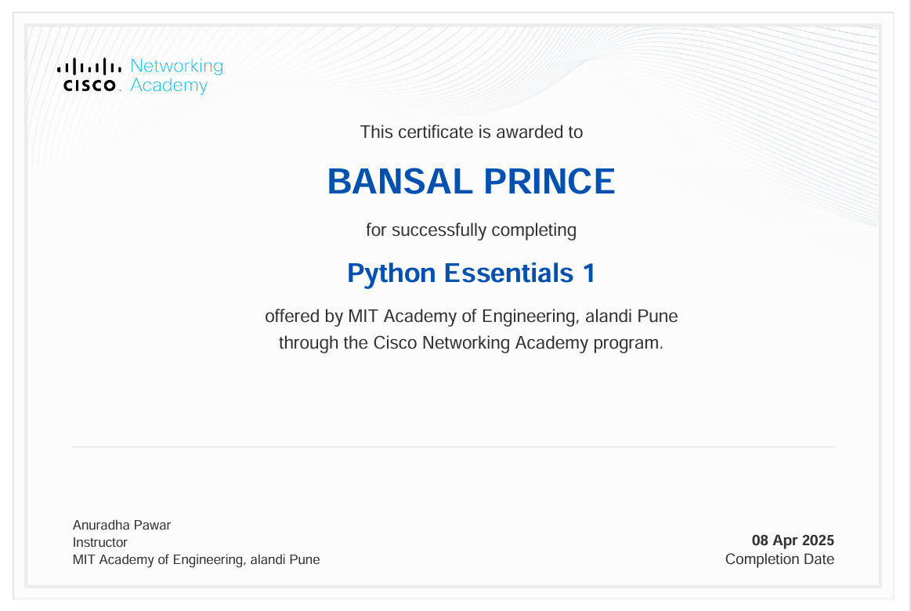

***PYTHON ESSENTIALS 2***

